•

Power BI

DAX Calculation
Best Practices and Guidelines
•
November 1, 2022

Contents
1. Objective 3
2. Introduction 4
3. DAX Engines
4. Data and Storage Types
5. DAX Syntax
6. DAX Common Functions
7. Evaluation Context
8. Tips and Best Practices
9. DAX Cheat Sheet
10. Reference

Objective

This document contains a DAX guide for Power BI practitioners covering the basics on syntax, formatting, most useful DAX functions, tips and best practices.

The document is meant to give a quick and easy introduction to address the core DAX concepts, understanding DAX engines, data types and DAX formulas used in calculations.

Introduction

DAX (Data Analytics Expressions) is a formula-based language used to compute calculated columns and calculated fields. Functions, constants and operators are used in DAX to create expressions and implement business logic in the data model.

DAX can only be used to filter/query a physical table, it cannot add, delete or update data in a table. It is designed for enhancing data modeling, reporting and analytics capabilities built specifically to work with relational data models

DAX is functional language. Every expression is a function call and function parameters can be, in turn, other function calls. The evaluation of parameters might lead to very complex query plans that DAX executes to compute the result.

DAX is the formula language that drives Power BI. With DAX you can:
-Add calculated columns and measures to your model, using intuitive syntax
-Go beyond the capabilities of traditional “grid-style” formulas, with powerful and flexible functions built specifically to work with relational data models
.
CALCULATED COLUMNS
Calculated columns allow you to add new, formula-based columns to tables
-Calculated columns refer to entire tables or columns
-Calculated columns generate values for each row, which are visible within tables in the Data view
-Calculated columns understand row context; they’re great for defining properties based on information in each row, but generally useless for aggregation (SUM, COUNT, etc.)

-As a rule of thumb, use calculated columns when you want to hardcode static/fixed values to each row in a table (or use the Query Editor)
-DO NOT use calculated columns for aggregation formulas, or to calculate fields for the “Values” area of a visualization (use measures instead)
-Calculated columns are typically used for filtering data, rather than creating numerical values
-Primarily used as rows, columns, slicers or filters

MEASURES
Measures are DAX formulas used to generate new calculated values
-Like calculated columns, measures reference entire tables or columns
-Unlike calculated columns, measure values aren’t visible within tables; they can only be “seen” within a visualization like a chart or matrix
-Measures are evaluated based on filter context, which means they recalculate when the fields or filters around them change (like when new row or column labels are pulled into a matrix or when new filters are applied to a report)

-As a rule of thumb, use measures (vs. calculated columns) when a single row can’t give you the answer (in other words, when you need to aggregate)
-Does not create new data in the tables themselves (doesn’t increase file size)
-Use measures to create numerical, calculated values that can be analyzed in the “values” field of a report visual

DAX Engines

DAX is powered by 2 internal engines (Formula engine and Storage engine) which work together to compress and encode raw data and evaluate DAX queries.
Note: Although these engines operate behind the scenes, knowing how they work will help you build advanced skills by understanding how DAX “thinks”

When a DAX query is executed, a combination of the Formula engine and the Storage
engine is used to resolve the query and return an answer.
In the process, the following steps are taken:
1. The query is transformed into an expression tree.
2. A logical query plan, containing the set of logical operations needed to execute
the query, is produced.
3. The logical query plan is transformed into a physical query plan, containing the
set of physical operations needed.
4. The physical query plan is executed, and data is retrieved from the storage
engine, allowing the result of the query to be calculated.
Steps 2 and 3 are particularly important when it comes to optimizing DAX queries. It is
these steps that produce the plans that we can read, allowing us to understand how the
query engine resolves our queries.

Formula Engine:
• Receives, interprets, and executes all DAX requests
• Processes the DAX query then generates a list of logical steps called a query plan
• Works with the datacache sent back from the storage engine to evaluate the DAX query and return a result
Storage Engine:
• Compresses and encodes raw data, and only communicates with the formula engine (doesn’t understand the DAX language)
• Receives a query plan from Formula Engine, executes it, and returns a datacache
Note: There are 2 types of storage engines based on the type of connection:
1. VertiPaq is used for data stored in-memory (connected to Power BI via import mode)
2. DirectQuery is used for data read directly from the source (i.e., AWS, GCP. Azure, PostgreSQL)

Query Evaluation
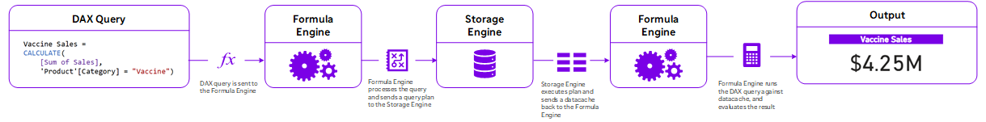

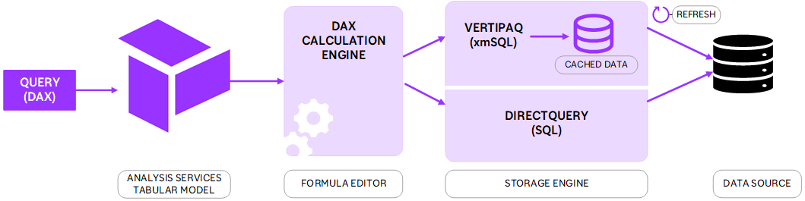

Data and Storage Types

While data types are typically automatically set, it is important to understand data types and how they apply to DAX formulas.

Errors in formulas or unexpected results, for example, are often caused by using a particular operator that cannot be used with a data type specified in an argument.

When you load new data into your model, the modeling engine will attempt to pick the
most efficient data type for a column, based on the values that it is importing for that
column. However, it is worth checking the data types that it selects, as it may not always
choose the most appropriate data type for your data needs.
For example, if a column currently contains only integer numbers, the modeling engine will pick the Whole Number data type. If this column subsequently contains fractional values, then the fractional part of these numbers will be lost when the data is imported. Worse still, if the column subsequently contains non-numeric data in the column, then you will get errors when the data is refreshed.

The type of implicit conversion that DAX performs is determined by the operator, it will
convert the data into the type required before it performs the requested operation.

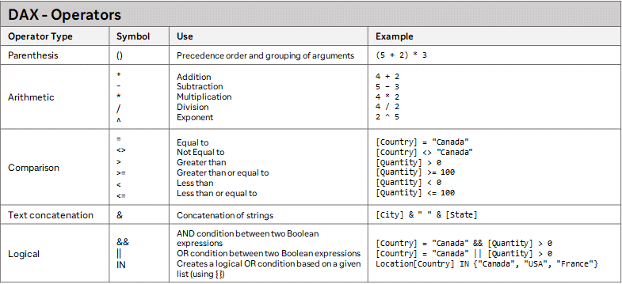


When using comparison expressions, you should consider the following points:
-Boolean values are treated as greater than string values.
-String values are treated as greater than numeric or date/time values.
-Numeric and date/time values are treated the same.

DAX Syntax

A DAX query consists of a function and a number of expressions.

An expression in DAX can be one or all of the following:
-Constant
-Operator
-Value: A value can be a table or table’s column value.

A parenthesis is a special type of operator which is used to give precedence or used for grouping of arguments.

DAX Basic Syntax:

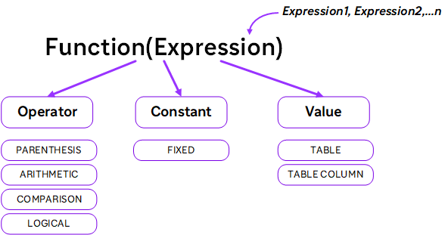

A DAX formula always starts with an equal sign (=). After the equals sign, you can provide any expression that evaluates to a scalar, or an expression that can be converted to a scalar. These include the following:
-A scalar constant, or expression that uses a scalar operator (+,-,*,/,>=,...,&&, ...)
-References to columns or tables. The DAX language always uses tables and columns as inputs to functions, never an array or arbitrary set of values.
-Operators, constants, and values provided as part of an expression.
-The result of a function and its required arguments. Some DAX functions return a table instead of a scalar and must be wrapped in a function that evaluates the table and returns a scalar; unless the table is a single column, single row table, then it is treated as a scalar value.
Most DAX functions require one or more arguments, which can include tables, columns, expressions, and values. However, some functions, such as PI, do not require any arguments, but always require parentheses to indicate the null argument. For example, you must always type PI(), not PI. You can also nest functions within other functions.
-Expressions. An expression can contain any or all of the following: operators, constants, or references to columns.

DAX Syntax Example:

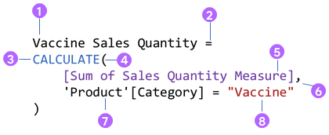
This DAX expression can be broken down as follows:
1. We start with the name we want to give to the measure, which in this case is Vaccine Sales Quantity.
2. The equals sign operator (=) defines the start of the DAX formula.
3. Our measure uses the CALCULATE function, which takes an expression or measure as the first argument and then modifies the filter context in which it is evaluated, using the filters given in the following parameters.
4. The opening parenthesis specifies the start of the arguments being passed to the CALCULATE function.
5. The measure Sum of Sales Quantity Measure calculates the total sum of values in the Sales Quantity column of the Sales table.
It is defined using this expression: Sum of Sales Quantity Measure = SUM ( Sales[Sale Quantity] )
6. The comma separates the expression passed as the first argument from the filter argument.
7. This gives the table and column name that we will use to modify the initial filter context used to evaluate the measure or expression given in the first argument.
8. This specifies the value that we want to filter the given column for, which will then define the new filter context.

DAX Common Functions
DAX includes a rich set of functions that allow you to perform aggregations, look up values in related tables, and manipulate text and perform time-based business intelligence. If you have used formulas in Excel, then many will appear very similar. However, you should remember that while Excel is based around cells, DAX works with columns and tables. By default, a DAX function will reference a complete column or table, and you will need to add filters to the formula if you require a particular subset of the data held in a table.
DAX functions can be grouped depending on their functionality.

The following lists each of these groups, along with a brief explanation of what functionality the functions in that group provide:
- Aggregation functions: These functions will aggregate the values in a column of a table or will apply aggregation to an expression that is evaluated by iterating over a table. Functions in this group will return a scalar value.
- Date and time functions: These functions are very similar to the date and time functions found in Excel, except that they make use of the date and time data types used in SQL Server.
- Filter functions: These functions can be used to look up values in related tables, using the relationships that exist between tables in your data model. They allow you to filter tables based on specific values and manipulate filter contexts.
- Information functions: These functions look at the table, column, or value passed in as an argument and tell you whether the value matches the type that is expected. Most of the functions in this group will return a value of TRUE or FALSE.
- Logical functions: These functions will apply a logical operation against the parameters passed and return a value of TRUE or FALSE depending on the results of the logical operation performed using the parameters.
- Mathematical and trigonometric functions: DAX provides a large number of mathematical and trigonometric functions that are very similar to those you will find in Excel, with the exception that there are some differences in the numeric data types used.
- Parent and child functions: Functions in this group help to manage data presented as a parent-child hierarchy in your data model.
- Statistical functions: These functions carry out statistically-related aggregations, such as percentiles, standard deviations, and variances
- Text functions: Functions in this group work with tables and columns and allow you to return part of a string, search for text within a string, or concatenate string values. There are also functions that allow you to format numbers and dates and times.
- Time-intelligence functions: These functions allow you to create time-based calculations that work with calendars and dates. When used with aggregations or calculations, it is possible to create data comparisons across different time periods. For example, using these functions, you can easily carry out year-onyear and year-to-date comparisons on data. To use these functions, you will need to include date tables in your data model.

DAX Common function categories with common examples:

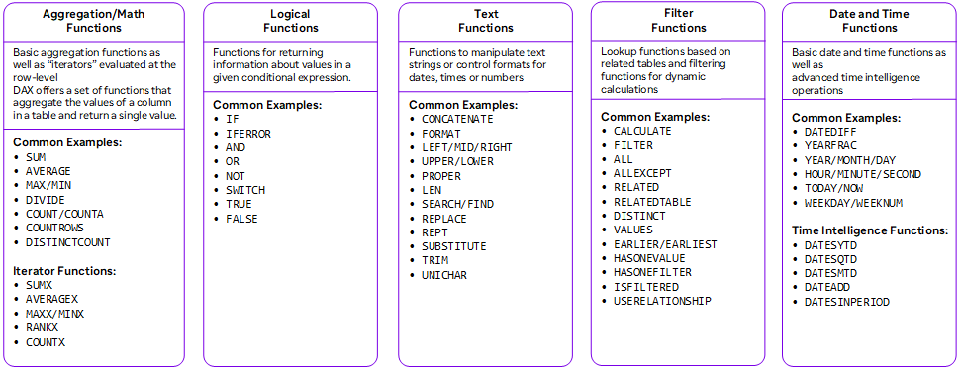

Aggregation Functions:

Common Math and Stats Functions
SUM() | Evaluates the sum of a column | =SUM(ColumnName)
AVERAGE() | Returns the average (arithmetic  mean) of all the numbers in a column | =AVERAGE(ColumnName)
MAX() | Returns the largest value in a column or between two scalar expressions | =MAX(ColumnName) or =MAX(Scalar1, [Scalar2])
MIN() | Returns the smallest value in a column or between two scalar expressions | =MIN(ColumnName) or =MIN(Scalar1, [Scalar2])
DIVIDE() | Performs division and returns the  alternate result (or blank) if div/0 | =DIVIDE(Numerator, Denominator, [AlternateResult])

COUNT, COUNTA, DISTINCTCOUNT & COUNTROWS
COUNT() | Counts the number of cells in a column that contain numbers | =SUM(ColumnName)
COUNTA() | Counts the number of non-empty cells in a column (numerical and non-numerical) | =AVERAGE(ColumnName)
DISTINCTCOUNT() | Counts the number of distinct or unique values in a column | =MAX(ColumnName) or =MAX(Scalar1, [Scalar2])
COUNTROWS() | Counts the number of rows in the specified table, or a table defined by an expression | =MIN(ColumnName) or =MIN(Scalar1, [Scalar2])


For large datasets (1M+ rows) using COUNTROWS & VALUES or COUNTROWS & DISTINCT may put less strain on the DAX engines than DISTINCTCOUNT
Logical Functions:

Common Logical Functions
IF() | Checks if a given condition is met, and returns one value if the condition is TRUE, and another if the condition is FALSE | =IF(LogicalTest, ResultIfTrue, [ResultIfFalse])
IFERROR() | Evaluates an expression and returns a specified value if the expression returns an error, otherwise returns the expression itself | =IFERROR(Value, ValueIfError)
AND() | Checks whether both arguments are TRUE, and returns TRUE if both arguments are TRUE, otherwise returns FALSE | =AND(Logical1, Logical2)
OR() | Checks whether one of the arguments is TRUE to return TRUE, and returns FALSE if both arguments are FALSE | =OR(Logical1, Logical2)
Note: Use the && and || operators if you want to include more than two conditions

SWITCH() | Evaluates an expression against a list of values and returns one of multiple possible expressions.  Switch is a simple and efficient function in DAX to help writing multiple IF statements much easier
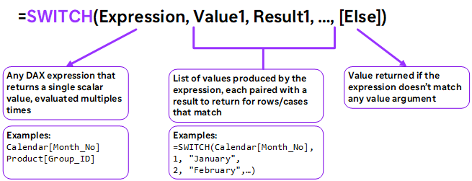

SWITCH(TRUE) is a common pattern to replace nested IF statements

Example:
=SWITCH(
TRUE(),
Calendar[Month_No]>9, "Q4",
Calendar[Month_No]>6, "Q3",
Calendar[Month_No]>3, "Q2",
"Q1"
)

COALESCE() | Returns the first argument that does not evaluate to BLANK. If all arguments  evaluate to BLANK, BLANK is returned.
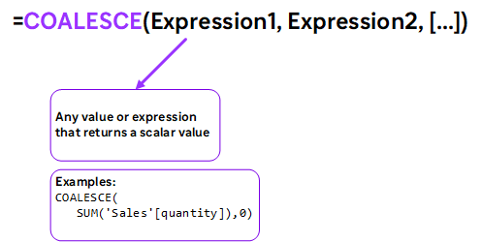

COALESCE replaces the IF + ISBLANK pattern, makes your code more readable, and can be optimized by the engines

Common Text Functions
LEN() | Returns the number of characters in a string | =LEN(Text)
CONCATENATE() | Joins two text strings into one | =CONCATENATE(Text1, Text2)  Note: Use the & operator as a shortcut, or to combine more than two strings
LEFT/MID/  RIGHT() | Returns a number of characters from the start/middle/end of a text string | =LEFT/RIGHT(Text, [NumChars])  =MID(Text, StartPosition, NumChars)
UPPER/LOWER/  PROPER() | Converts letters in a string to  upper/lower/proper case | =UPPER/LOWER/PROPER(Text)
SUBSTITUTE() | Replaces an instance of existing text with new text in a string | =SUBSTITUTE(Text, OldText, NewText,  [InstanceNumber])
SEARCH() | Returns the position where a specified string or character is found, reading left to right | =SEARCH(FindText, WithinText,  [StartPosition], [NotFoundValue])

Common Date/Time Functions
DAY/MONTH/  YEAR() | Returns the day of the month (1-31), month of the year (1-12), or year of a given date | =DAY/MONTH/YEAR(Date)
HOUR/MINUTE/  SECOND() | Returns the hour (0-23), minute (0-59), or second (0-59) of a given datetime value | =HOUR/MINUTE/SECOND(Datetime)
TODAY/NOW() | Returns the current date or exact time | =TODAY/NOW()
WEEKDAY/  WEEKNUM() | Returns a weekday number from 1 (Sunday) to 7 (Saturday), or the week # of the year | =WEEKDAY/WEEKNUM(Date, [ReturnType])
EOMONTH() | Returns the date of the last day of the  month, +/- a specified number of months | =EOMONTH(StartDate, Months)
DATEDIFF() | Returns the difference between two dates, based on a selected interval | =DATEDIFF(Date1, Date2, Interval)

Common Filter and Relationship Functions
CALCULATE() | Evaluates a given expression or formula under a set of defined filters | =CALCULATE(Expression, [Filter1], [Filter2],…)
FILTER() | This returns a filtered table or table expression using a Boolean expression that is used to evaluate each row of the table | =FILTER(Table, FilterExpression)
ALL() | Returns all rows in a table, or all values in a column, ignoring any filters that have been applied | =ALL(Table or ColumnName, [ColumnName1], [ColumnName2],…)
ALLEXCEPT() | This is similar to the ALL function in that it returns a table that includes all of the values for the combination of columns from the specified table,  excluding the specified columns. Like the ALL function, it can be used with the CALCULATE and ALCULATETABLE functions to remove filters from all but the specified columns. | =ALLEXCEPT ( TableName, [ColumnName1],[ColumnName2]…)
DISTINCT() | Returns a one-column table that contains the distinct values from the specified column. | =DISTINCT(ColumnName or Table Expression)
VALUES() | Returns a one-column table that contains the distinct values from the specified column. This function is similar to DISTINCT function, but VALUES function can add blank values | =VALUES(TableName or ColumnName)
RELATED() | Returns related values in each row of a table based on relationships with other tables | =RELATED(ColumnName)
USERELATIONSHIP() | Specifies an existing relationship to be used in the evaluation of a DAX expression, defined by naming, as arguments, the two columns that serve as endpoints | =USERELATIONSHIP(ColumnName1 ColumnName2)
CROSSFILTER() | Specifies cross filtering direction to be used for the duration of the DAX expression. | =CROSSFILTER(LeftColumnName, RightColumnName2, CrossFilterType)

Using the CALCULATE function

CALCULATE() | CALCULATE is a powerful DAX function which is commonly used to modify filter context. (Refer to context transition in section 7 of this document.
Common use cases:
• Simplifying measures by adding new filter context that would normally use multiple nested functions
• Modifying filter context to override preexisting filters using modifiers like ALL, KEEPFILTERS or REMOVEFILTERS
• Creating calculated inputs for measures like % of total, % of category, etc.
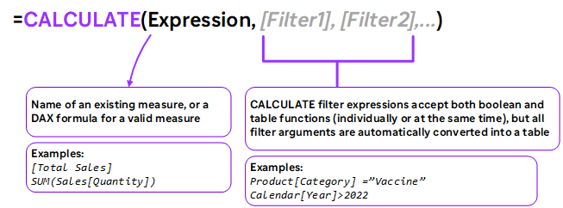

The function has only one mandatory argument: the expression that is to be evaluated. It will then take one to many optional filter arguments. These optional filter arguments are combined to form the overall filter, which is applied to the expression given as the first argument.
Some restrictions apply to Boolean expressions used as arguments:
-Expressions cannot reference a measure.
-Expressions cannot use a nested CALCULATE function.
-Expressions cannot use any function that scans a table or returns a table, including aggregation functions.

The power of the CALCULATE function comes from its ability to alter the existing filter context of the expression passed in the first argument, by the n number of filter conditions specified by the following arguments. This is done according to the following:
-If the filter context specified by a filter condition already exists, it will override the existing filter context with the new one specified in the expression.
-If the filter context does not exist at all, it will add a new one according to the filter conditions specified

Example:
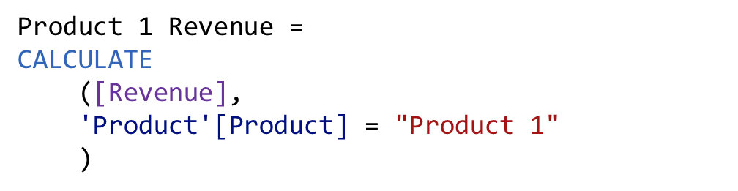

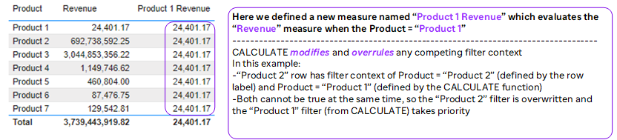

CALCULATE creates new filter context

Calculation steps
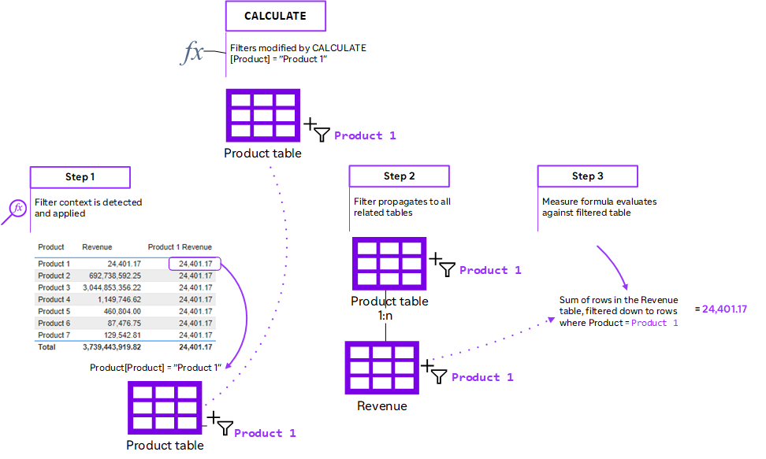

CALCULATE evaluation follow these steps:
- CALCULATE evaluates all the explicit filter arguments in the original evaluation context, each one independently from the others. This includes both the original row contexts (if any) and the original filter context. Once this evaluation is finished, CALCULATE starts building the new filter context.
- CALCULATE makes a copy of the original filter context to prepare the new filter context. It discards the original row contexts, because the new evaluation context will not contain any row context.
- CALCULATE performs the context transition. It uses the current value of columns in the original row contexts to provide a filter with a unique value for all the columns currently being iterated in the original row contexts. This filter may or may not contain one individual row. There is no guarantee that the new filter context contains a single row at this point. If there are no row contexts active, this step is skipped. Once all implicit filters created by the context transition are applied to the new filter context, CALCULATE moves on to the next step.
- CALCULATE evaluates the CALCULATE modifiers used in filter arguments: USERELATIONSHIP, CROSSFILTER, ALL, ALLEXCEPT, ALLSELECTED, and ALLNOBLANKROW. This step happens after step 3. This is very important, because it means that one can remove the effects of the context transition by using ALL as a filter argument. The CALCULATE modifiers are applied after the context transition, so they can alter the effects of the context transition.
- CALCULATE applies the explicit filter arguments evaluated at 1. to the new filter context generated after step 4. These filter arguments are applied to the new filter context once the context transition has happened so they can overwrite it, after filter removal — their filter is not removed by any ALL* modifier — and after the relationship architecture has been updated. However, the evaluation of filter arguments happens in the original filter context, and it is not affected by any other modifier or filter within the same CALCULATE function. If a filter argument is modified by KEEPFILTERS, the filter is added to the filter context without overwriting existing filters over the same column(s).


-Filter expressions in CALCULATE require simple, fixed values; you cannot create filters based on other measures)
-Filters accepted by CALCULATE can be of two types:
- List of values, in the form of a table expression. In that case, provide the exact list of values you want to see in the new filter context. The filter can be a table with a single column or with many columns, as is the case of a filter on a whole table
- Boolean conditions, such as Product[Product]=”Product 1”. These filters need to work on a single column because the result has to be a list of values of a single column.
-Every filter argument can be either a filter removal (such as ALL, ALLEXCEPT, ALLNOBLANKROW), a filter restore (ALLSELECTED), or a table expression returning a list of values for one or more columns or for an entire expanded table.
-When a filter argument has the form of a predicate with a single column reference, the expression is embedded into a FILTER expression that filters all the values of the referenced column. For example, the predicate shown in the first expression is internally converted in the second expression.
-When you write a CALCULATE statement, all the filter arguments are table expressions, such as a list of values for one or more columns, or for an entire table.
-You can also use the RELATED function to check for conditions in tables related to the table specified as the table parameter of the FILTER function.
-You should also remember that any explicit filters you create using the FILTER function are on top of any implicit filters that may be coming from external sources such as slicers.
Common modifiers used with CALCULATE to change the filter context

FILTER() | Returns a table that represents a subset of another table or expression
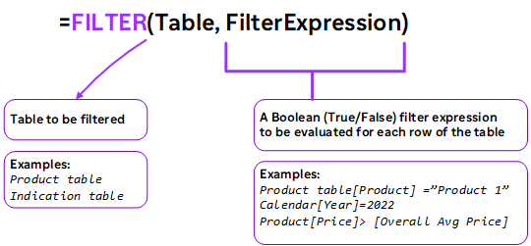

CALCULATE is a powerful function but there is a limitation to filters that it can apply.
The filters will only work when:
-There is a value on the right-hand side of the equation
-There is a column name on the left-hand side of the equation

The example below illustrates the difference between the way CALCULATE, FILTER and KEEPFILTERS filter data.
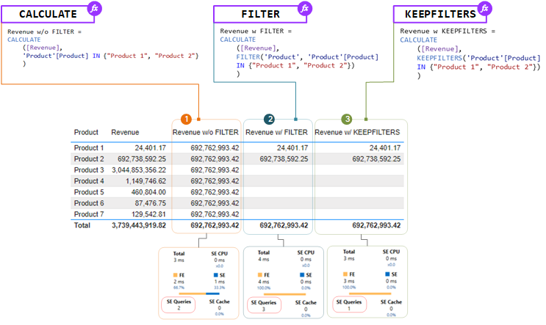
1. CALCULATE without FILTER: replaces the filter context with a new constraint that the Product should be Product 1 and Product 2, which results in the same figure appearing in every row.
In this example, when the formula starts the evaluation in a filter context where the only value = Product 3, CALCULATE evaluates a new condition (Product = Product 1, Product 2) and when it had to apply it to the new filter context, it replaces the existing condition, removing the filter on Product 3 and replacing it with Product 1, Product 2. This happens for all the rows and that’s why we see the same figure for all rows.

2. CALCULATE with FILTER: applies the filter context hence calculating revenue for products selected and applies an additional constraint that products should be Product 1 and Product 2 which results in displaying the figures for the selections in FILTER.
When using CALCULATE with FILTER the filters are evaluated under the original filter context, not under the filter context created by CALCULATE.
First thing CALCULATE will do is evaluate the FILTER expression. FILTER is an iterator and iterates over the Products table. FILTER will not see all the products, it will be able to see only rows that are visible under the current filter context (slicer, page filter, visualization). For each product row FILTER will iterate and it will return product matching the filter criteria and the result of the filter is now incorporated in the result of FILTER and table will be returned with the rows that match the criteria. Next, CALCULATE will step in to create its new filter context under which it computes its expression.

3. CALCULATE with KEEPFILTERS: here is an improved definition that uses a Boolean expression instead of a table expression. KEEPFILTERS ensures any existing filters applied to the Product column are preserved and not overwritten. The Product filter being generated by the table visual is preserved in the filter context , despite the column being used as a filter parameter of the CALCULATE function. As expected, we only get a figure against the Products included in the selection.
In the preceding screenshot we captured some performance metrics and we can see the query with CALCULATE and KEEPFILTERS performed better than the query with FILTER and the query with FILTER executed an extra storage engine query. We can also see that the query with FILTER spent more time on the formula engine than the other queries, this difference can become significant with higher volumes of data.


FILTER is used to add new filter context, and can handle more complex filter expressions than CALCULATE (by referencing measures, for example)
Since FILTER returns an entire table, it’s almost always used as an input to other functions, like CALCULATE or SUMX.
Since FILTER iterates through each row in a table, it can be slow and processor-intensive; don’t use FILTER if a CALCULATE function will accomplish the same thing.
It's recommended you pass filter arguments as Boolean expressions (e.g., using KEEPFILTERS), whenever possible. It's because Import model tables are in-memory column stores. They are explicitly optimized to efficiently filter columns in this way.
FILTER function should only be used when necessary. You can use it to perform filter complex column comparisons.
These column comparisons can involve:
-Measures
-Other columns
-Using the OR DAX function, or the OR logical operator (||)
Remember that when using CALCULATE with FILTER, before doing anything else CALCULATE evaluates the FILTER expression as its first step.
All filter arguments of CALCULATE are evaluated independently, then they are put in a logical AND together. Finally, they are used to determine the newly created filter context.
There is a precedence order between context transition and filter arguments of CALCULATE. CALCULATE applies the filters after if it has performed context transition. Thus, filters can override the context created by the transition.

ALL() | Returns all rows in a table, or all values in a column, ignoring any filters that have been applied
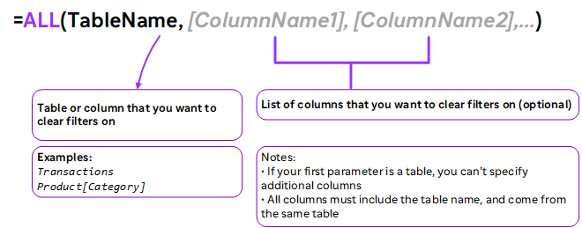


Instead of adding filter context, ALL removes it. This is often used when you need unfiltered values that won’t react to changes in filter context (i.e. % of Total, where the denominator needs to remain fixed)
ALL is a table function that returns all the rows of a table or of a set of columns. This is the correct behavior of ALL whenever that result is actually required.
In the very specific case of CALCULATE filters – and only in this specific case – ALL is not used to retrieve values from a table. Instead, ALL is used to remove filters from the filter context. Though the function name is the same, the semantics of the function is completely different.
Microsoft introduced the REMOVEFILTERS function in Power BI since October 2019.
REMOVEFILTERS is like ALL, but it can only be used as a filter argument in CALCULATE.

Examples:

-ALL ignores the filter coming from one/multiple tables

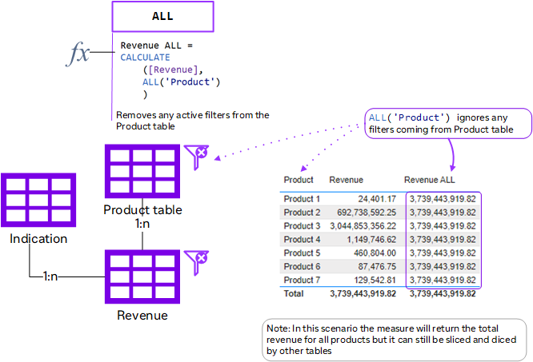

-ALL ignores filters from All tables

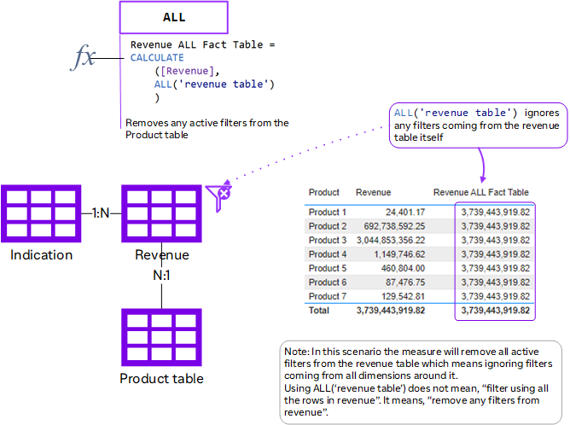

-Using ALL without input parameter: remove all filters

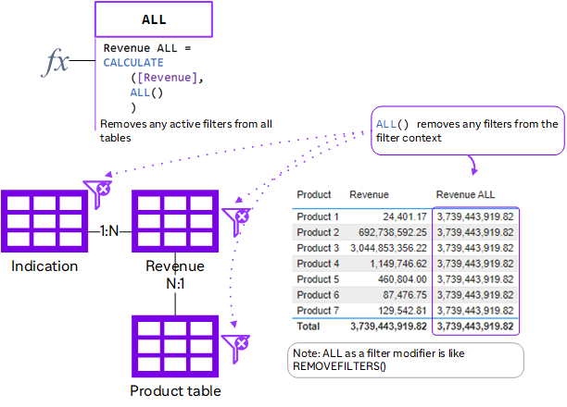

ALLEXCEPT() | Similar to the ALL function in that it returns a table that includes all of the values for the combination of columns from the specified table, excluding the specified columns. Like the ALL function, it can be used with the CALCULATE and CALCULATETABLE functions to remove filters from all but the specified columns.
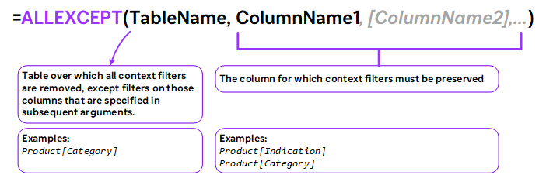

Example:

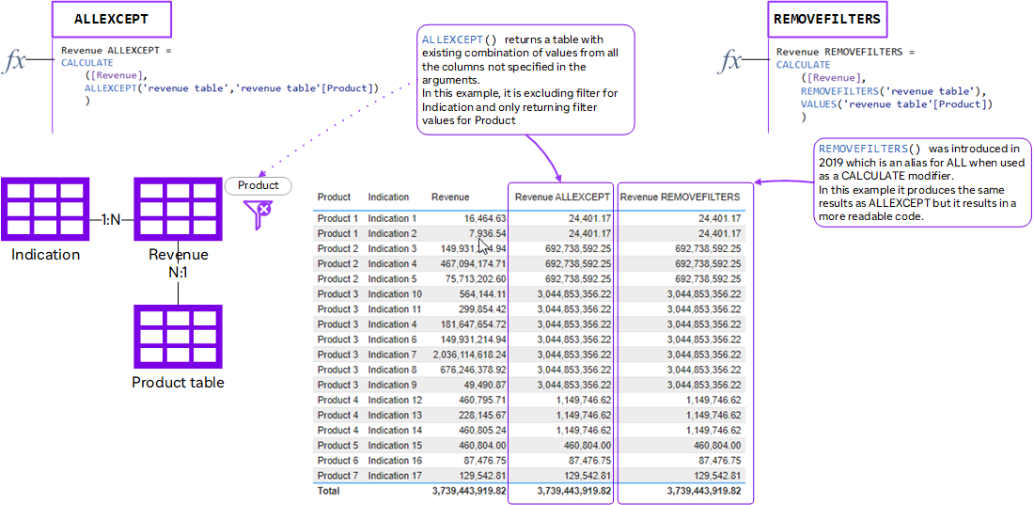


-ALLEXCEPT is very similar to the ALL function. However, instead of specifying the columns to be removed from the filter context, you specify the columns that should remain.
-It will remove all the columns in the specified table, except those given as the column parameters.
-Unlike the ALL function, you must specify both the table name and one or more column names.
-The ALLEXCEPT function is useful where you have lots of filters being applied to the filter context.
-Suppose you had a case where there were 30 filters applied and you only wanted to retain one of them for your calculation. In such a case, if you were using the ALL function, you would need to pass 29 columns as parameters.
-With the ALLEXCEPT function, you would only need to pass the table name and the name of the column that you wanted to retain the filter for.

ALLSELECTED() | This returns a table that includes all of the rows of a specified table or all of the values in a column or combination of columns. It ignores filters applied inside the query, while retaining any external filters. The ALLSELECTED function can be used with the CALCULATE and CALCULATETABLE functions to restore explicit filters and contexts.
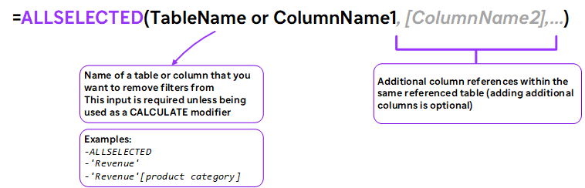

Example:

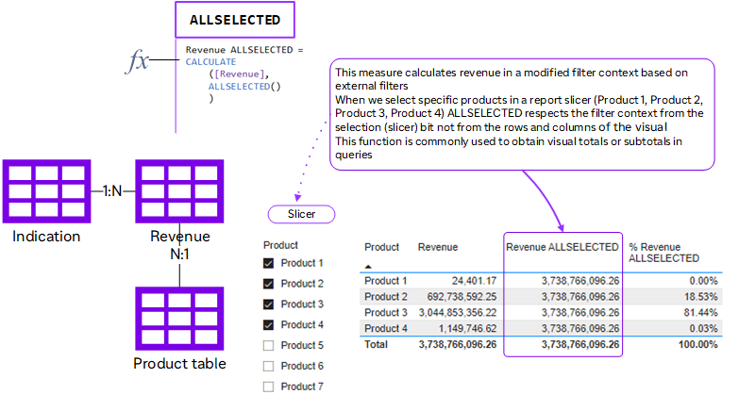


-If there is one argument, the argument is either table name or column name. If there is more than one argument, they must be columns from the same table.
-This function is different from ALL() because it retains all filters explicitly set within the query, and it retains all context filters other than row and column filters.
-ALLSELECTED respects existing filter context except row and column filters within a visual. This function can be used to obtain visual totals or subtotals in queries.
-ALLSELECTED is specifically designed to achieve visual calculations as ALLSELECTED removes the filter created by the current visual (matrix) and it restores the previous filter context that is the filter created by the slicer.
-You can use ALLSELECTED in a measure that is directly put in a report, but you should never call a measure that contains ALLSELECTED

DISTINCT() | Returns a single column table of unique values when a column name is given.  If a table is supplied, DISTINCT returns all unique combinations of values.
DISTINCT (column) accepts a column reference as a parameter and it returns a one-column table that contains all of the distinct (unique) values of that column as visible in the current filter context. Put simply, duplicate values are removed, and only unique values are returned. If there are any blank values in a column, DISTINCT will exclude them. When used in a measure, the DISTINCT function must be used in conjunction with another function that counts, filters, or aggregates the returned distinct values.

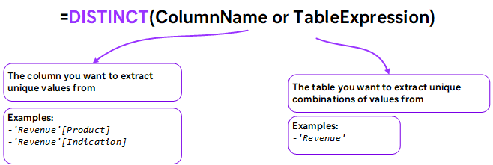


If you are trying to build a relational model from a single, blended table, you can use DISTINCT to create new lookup/dimension tables by extracting unique values from fields in your data table

VALUES() | Returns a single column table of unique values when a column name is given. If a table name is supplied, VALUES returns the entire table (including duplicates) plus a blank row
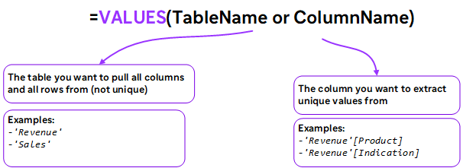

VALUES VS. DISTINCT: Blank Row

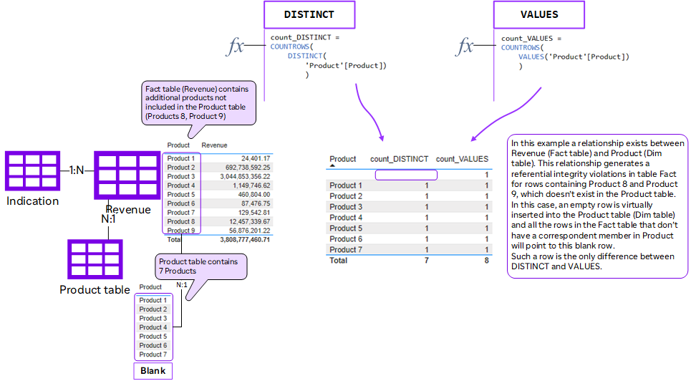

-Instead of throwing an error when a value is missing from a lookup table, the DAX engine adds a blank row (which will appear in visuals when missing values are present)
-Different table functions handle the presence of this blank row differently; for example, VALUES will always show the blank row but DISTINCT will not
-If you think you might have missing values in your lookup tables (or aren’t sure), use VALUES to check.

RELATED() | Returns a single column table of unique values when a column name is given.  If a table is supplied, DISTINCT returns all unique combinations of values.
You use RELATED when you are scanning a table, and within that row context you want to access rows in related tables.

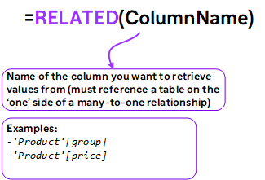


-The RELATED function doesn’t really perform an operation, it just “opens the door” to access columns from an expanded table.
-The RELATED function is useful to navigate through relationships within a row context.
-The RELATED function pulls the values from the ONE sides of the relationship to the other side. This means one-to-one relationship and one-to-many relationship works just fine with this function. But not the many-to-many relationship. Also, the one-to-many relationship only allows you to use the RELATED when you are on the MANY side of the relationship, not the ONE.

USERELATIONSHIP() | Specifies an existing relationship to be used in the evaluation of a DAX expression, defined by naming, as arguments, the two columns that serve as endpoints
If two tables are linked by more than one relationship, you can decide which relationship to activate by using USERELATIONSHIP (you can only have one active relationship between any two tables)

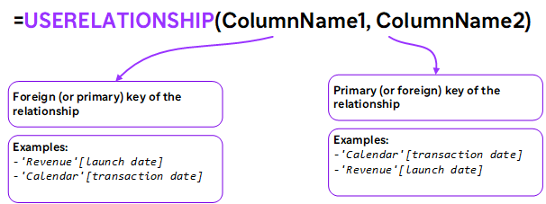


-USERELATIONSHIPS can only be used in functions which accept a filter parameter (CALCULATE, TOTALYTD, etc.)
-If you have multiple date columns connected to a single calendar table, USERELATIONSHIP is a great way to force measures to use inactive relationships without having to manually activate them in your model.
-USERELATIONSHIP is a CALCULATE modifier, which instructs CALCULATE to temporarily activate the relationship. When CALCULATE has computed its result, the default relationship becomes active again.
-Up to 10 USERELATIONSHIP functions can be nested; however, your expression might have a deeper level of nesting, ie. the following sample expression is nested 3 levels deep but only 2 for USERELATIONSHIP: =CALCULATE(CALCULATE( CALCULATE( <anyExpression>, USERELATIONSHIP( t1[colA], t2[colB])), t99[colZ]=999), USERELATIONSHIP( t1[colA], t2[colA])).

CROSSFILTER() | Specifies cross filtering direction to be used for the duration of the DAX expression.  The relationship is defined by naming the two columns that serve as endpoints
CROSSFILTER is a useful function to change the direction of the relationship. You can use this method instead of changing the direction in the relationship itself.

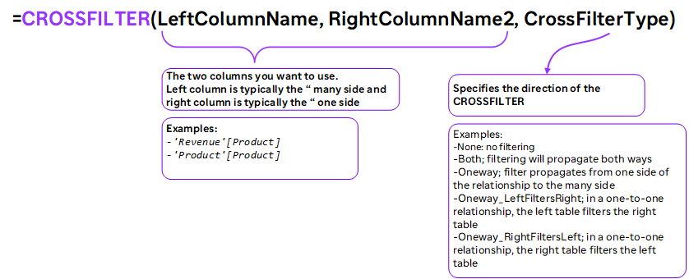


-Instead of bidirectional relationships, use CROSSFILTER to enable two-way filtering ONLY in specific cases.
-Always consider a good modeling to cover the requirement without the need of both-directional relationship.
-If you have to create a both-directional relationship regardless of the best practice modeling, then use the CROSSFILTER approach as much as possible, it can be better for the performance. The performance impact would be only when you use that particular measure in a report page, not always.
-The CROSSFILTER requires an existing relationship between the two tables.
-If CALCULATE expressions are nested, and more than one CALCULATE expression contains a CROSSFILTER function, then the innermost CROSSFILTER is the one that prevails in case of a conflict or ambiguity.
-This function is not supported for use in DirectQuery mode when used in calculated columns or row-level security (RLS) rules.

Evaluation Context

DAX formulas in Power BI are dynamic, and they change according to the context in which they were created. It’s important to have an understanding of how contexts work in DAX, as it can help save you a lot of headaches when you run into confusing errors in your formulas.

Evaluation context is the environment in which a DAX formula is evaluated in. When we write a DAX formula it gets evaluated within an environment. The DAX formula evaluated will be directly dependent on the evaluation context. This means the result returned can be different depending on the context, even if the DAX formula used is the same. There are two main types of evaluation contexts in DAX: filter context and row context.

Filter & row context tells DAX exactly how to evaluate measures and calculated columns in your data model.

Understanding Filter Context
The filter context is the combination of filters that is applied before the evaluation of a DAX expression. Its purpose is to filter tables.
In SQL this would refer to the WHERE clause. Because of the existence of a context, the result of the same formula can be different in different cells. There are two different ways in which filters are applied.

Implicit Filters
Implicit filters you find in the user interface. When you put a measure in a visualization, the result is different in each cell because it is calculated in a different context.
This context is affected by the elements in red in below picture. The elements affecting the filter context are:
1. Rows in a visual
2. Slicers in a report
3. Filters in a report
4. Columns in a visual

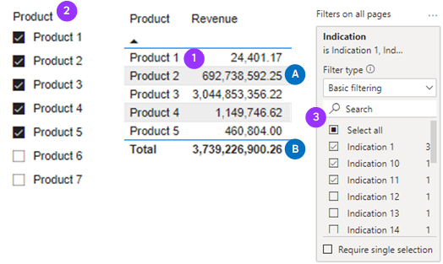
Each of these elements contributes to the filter context. The DAX engine prepares this context before evaluating a DAX expression. Within the same visual, a measure can use different contexts for a calculation, depending on the location in the visual/table.
In the above screenshot, you can see that value A is filtered by elements 1, 2, 3 whereas in the same visual, the total B is only filtered by 2 and 3. The same expression is evaluated, but without the filter on Product.

Explicit Filters
Next to the implicit filters, one can also apply more explicit filters. They can be found in the DAX expressions. The filter arguments in a DAX expression, restraint or include values in a column or table.

In other words, these filter arguments take the implicit filter context and then either add or remove a filter. Functions like ALL, ALLSELECTED, REMOVEFILTERS, FILTER, KEEPFILTERS are often used to do this.

Understanding Row Context
Row context is used to calculate an expression row-by-row. The row context is a special iteration mechanism which takes in consideration the row it is currently on at the time the DAX formula is evaluates. This means that it performs a calculation row by row within a table. A simple example of a row context is the following.

Row Context: Calculated Column
To make more sense of Row Context, let’s start off with Calculated Columns which apply Row Context.
Below is sample of a calculated column used to retrieve total sales by multiplying unit price by units sold:

Total Sales = sales_table[Unit Price] * sales_table[Units Sold]

Row Context within a Calculated Column always starts with the first row and finishes on the last row. It iterates through the entire table the calculated column has been placed in, starting with the first row and evaluating the expression, then moving on the second row and evaluating the expression until it repeats the iteration for all records in the table.
Looking at the below screenshot we can see that the Calculated Column ‘Total Sales’ has produced a value for each row.

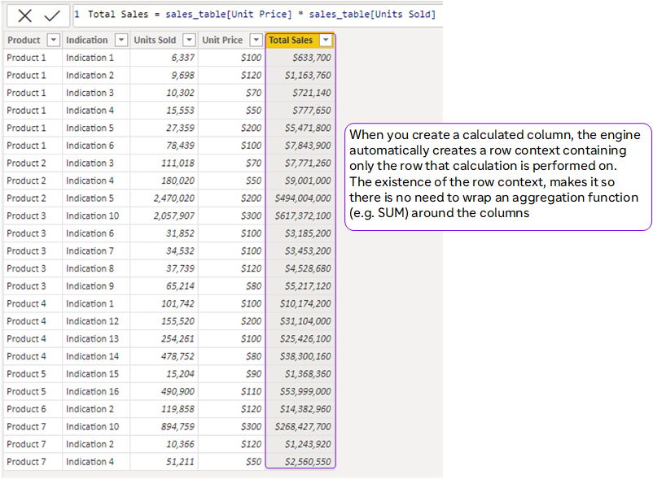

Row Context: Iterator functions (X-Functions)
Row context is involved both when creating calculated columns and when you’re using certain measures to evaluate an expression against a column in a table for which we need to be able to explicitly create a row context. We can do this using one of the iterator functions.
These integrator functions or X functions will iterate over a specified table, evaluating a given expression against each row in that table, before applying some form of aggregation.
Examples of X functions include SUMX, AVERAGEX, COUNTX, MAXX, MINX and RANKX. In effect, they create a temporary calculated column that is then used to perform the aggregation, before being dropped.
All these X functions have a corresponding non-iterating aggregation function.
Each of the non-iterating aggregation functions uses the X version of their function behind the scenes, in a process known as syntax sugar.


Syntax sugar is a process whereby the language contains simplified versions of more complex functionality, making it easier for people to read and write.

You can also perform previous Total Sales calculation without a calculated column. In this case you would use a measure, like the one below:

Total Sales =
SUMX(sales_table,
sales_table[Unit Price]*sales_table[Units Sold])

Measures don’t have a row context by default. However, the measures that are considered iterators automatically create a row context. SUMX being an iterator, it requires as first argument a table to iterate.

In this case we provide the sales table. It then creates a row context within the sales table and performs the calculation in the second argument row-by-row. The existence of the row context then allows you to reference column names as in previous example.

In summary, the row context does not filter tables in any way. The filtering is done by the filter context (implicit and explicit filters). However, to perform a calculation row-by-row the row context is used.

Filter Context | Row Context
• Filter context filters the tables in your data model  • DAX creates filter context when dimensions are added to rows, columns, slicers & filters in a report  • CALCULATE can be used to systematically create or modify existing filter context  • Filter context always travels propagates) from the 1 side to the MANY side of a table relationship | • Row context iterates through the rows in a table  • DAX creates row context when you add calculated columns to your data model  • Iterator functions (SUMX, RANKX, etc.) use row context to evaluate row-level calculations  • Row context doesn't automatically propagate through table relationships (need to use RELATED or RELATEDTABLE functions)

Tips and Best Practices

In this section we’ll cover some common techniques and best practices for working efficiently with DAX, including shortcuts, comments, measure tables, and variables.

It is important to optimize your data model and load speed of the visualization objects for a better user experience. This is especially important when dealing with large dataset as the impact would be greater.

DAX Shortcuts

Action | Keyboard Shortcut
Insert Line Below | Shift + Enter
Insert Line Above | Control + Shift + Enter
Select Current Line | Control + I
Cut Current Line | Control + X
Paste Cut Line | Control + V
Duplicate Current Row | Shift + Alt + 
Go to Line | Control + G
Enlarge Code Type | Control + Mouse Scroll
If you use a square bracket “[“ when you call a measure, you’ll avoid having to filter through function names that also start with the same letter(s) as your measure name

Best Practices

Calculated Columns vs Measures
-Don’t use a calculated column when a measure will do the trick
•Only use calculated columns to “stamp” static, fixed values to each row in a table
•Use measures when aggregation is necessary, or to create dynamic values in a report
-Write measures for even the simplest calculations (i.e., Sum of Sales)
•Once you create a measure it can be used anywhere in the report and as an input to other, more complex calculations (no implicit measures)
-Break measures down into simple, component parts
•DAX is a difficult language to master; focus on practicing and understanding simple components at first, then assemble them into more advanced formulas
-Reference columns with the table name, and measures alone
•Using “fully qualified” column references (preceded by the table name) helps make formulas more readable and intuitive, and differentiates them from measure references

Formatting and Commenting code
-Formatting is key for readability. Use Shift+Enter to split out and indent each component of your DAX formulas to make them more human readable.
-While there is no official set of rules for formatting your DAX code, following some good formatting guidelines is essential if you want to make DAX easier to work with. Not only is poorly formatted DAX code difficult to read, but it is almost impossible to interpret. In addition, well-formatted DAX code is much easier to
debug when things don't work as expected.
-Since it is a functional language, a DAX expression will consist of a call to a DAX function, along with some parameters. These parameters can be static arguments, or they can be calls to other DAX functions. All but the simplest DAX expressions will consist of nested functions calls, often many layers deep.

The following example shows a relatively simple DAX expression that creates a measure to calculate the month-over-month percentage change in sales amount:

Even with a simple measure like this, with no formatting, the DAX code is difficult to read and understand.
The following example is the same measure, but this time it is formatted and also makes uses of a variable to store the value of the previous month's sales amount:

Now, it is easier to understand what the measure is doing. This can be broken down as follows:
1. First, it calculates the total sales amount for a previous month's date.
2. It stores this value in the varPrevMonth variable.
3. Then, it takes a value of varPrevMonth away from the total sales amount for the
current date.
4. Finally, it divides the value from the previous step by the value of
varPrevMonth.

The following are a basic set of formatting rules that you should follow to make your DAX code easier to read:
-Always place a new function call on a new line.
-Place the first bracket for a function call on the same line as the function.
-If a function only has one argument, then place that on the same line as the
function call.
-If a function has more than one argument, then place each argument on a new
line.
-If an argument is on a new line, indent four spaces from the function call.
-The closing bracket for a function call should be lined up with the function call,
and not indented.
-Keep commas separating arguments on the same line as the previous argument.
-If you have to spread a function, call over more than one line, ensure that
operators are the first characters.
-Use a space after brackets.
-Use a space after operators.
-Use a space after a comma, but not before it.

When referencing table names, calculated columns, and measures, follow these guidelines:
-Do not use a space between the table name and the column name.
-Only use single quotes for table names when required (that is, when table names
have spaces).
-Ensure you always include the table name with column references. It should be
written as TableName[ColumnName].
-Do not include a table name with a measure reference. It should be written as
[MeasureName].

Comments can help other users interpret your code, and can be particularly helpful for complex queries with multiple lines, nested functions, etc.

Comment Type | Marker
Single Line Comment | -- or //
Multi Line Comment | /* … */

Measures tables
-A measures table is essentially just a placeholder table that acts as a folder for your measures.
-Creating a separate table to contain your DAX measures is a great way to stay
organized (you can even group your measures into folders within the table)

The generic pattern to follow is to:
-Create a table with a single column.
-Add at least one measure to the table. There are 2 ways to do this.
- Method 1: Move measures individually
Right click on an individual measure
Go to Modeling\Home Table and change the location to the Measure table
- Method 2: With the new model view in Power BI Desktop, it is now possible to drag and drop measures between tables.
-Hide or delete the column leaving the table showing measures only.
-Force the measure icon for the table (collapse and expand the fields panel on the right).

Options to create measure table:
-Option 1: Using DAX table constructor
- Click on Modeling\New Table
- Write the following DAX table function (note the space before the word Measures).
This makes the table float to the top of the list.
[ Measures] = {Blank()}

-Option 2: Enter data
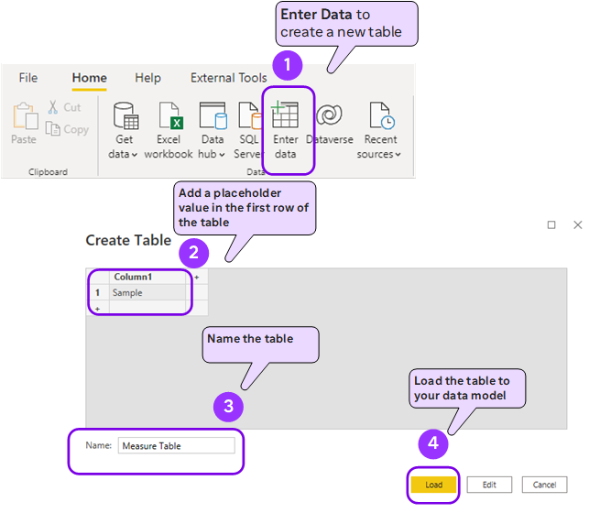

To create a sub folder (in a main table or a measure table):
-Go to the Model view
-Select table Click the ellipsis in the top right of the table, select Measures
-Go to Properties\Display Folder and type a name of a folder
-You can also create nested sub folders as MainFolder\SubFolder

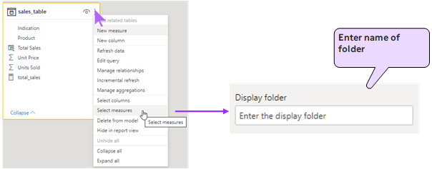

Alternatives to Using Measure Tables:
-It is possible to create sub folders for measures using the latest versions of Power BI desktop. You can make sub folders float to the top of the table using a suitable name for the folder (i.e., it will sort alphabetically).
-It is also possible to hide all columns in a data table just leaving the measures visible. When you do this the data table behaves like a measure table.
There are some downsides when you hide all the columns
- You remove the possibility to drag and drop the column itself (e.g., find the MAX(Sales[Quantity]) without writing a measure).
- You may need one of the columns for further analysis

Variables
Variables (VAR) are DAX expressions which can be reused multiple times within a query, and are commonly used for two key purposes:
•Readability: Variables make complex code more human readable
•Performance: Variables are only evaluated once no matter how often they are used within a query


Variables allow you to store hard coded values or the results that are returned by a DAX expression. They can store both scalar values and tables and can be used within the definitions of calculated columns, measures, and tables.
A variable is declared using the VAR keyword.
DAX queries which use variables must include two key components: the
Declaration expression and the return expression:

VAR <variableName> = <DAX expression>
RETURN <DAX expression including variableName>

Example:
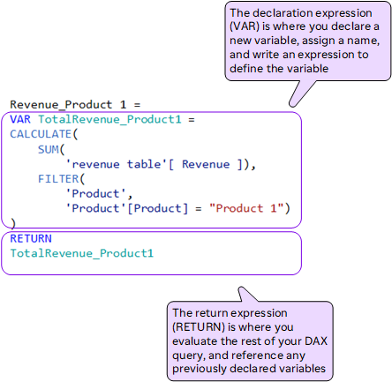

When defining an expression, you can use as many variables as you need; each variable is declared using its own VAR keyword. Variables can be used for declaration purposes when defining other variables, as well as to return values in the expression given after the RETURN keyword.
The RETURN keyword is used to define the return expression, which is then used to define the calculated column, measure, or table.
Once a variable has been declared and initialized, it cannot be assigned another value.
So, for example, the following would produce an error:
VAR varOne = 1
VAR varOne = varOne + 1
RETURN varOne

Instead, you should declare a second variable and then use the first variable as part of the second variable's declaration. Then, you can use the second variable in the expression being used with the RETURN keyword, as shown in the following example:
VAR varOne = 1
VAR varTwo = varOne + 1
RETURN varTwo

Variables in DAX are not declared with data types; they are automatically allocated to the type of the value being assigned to them. When using variables of different types with an operator, they will follow the same rules of implicit data type assignment.

When it comes to naming variables, you cannot use names that are already in use by tables, or names that are used as DAX keywords. In addition, the following are the limitations when it comes to naming a variable:
-Variable names cannot contain blank spaces
-Delimiters such as square brackets and apostrophes are not allowed
-The supported characters are a-z, A-Z, 0-9
-0-9 cannot be used as a first character
-A double underscore (__) is allowed as a prefix of a name

What variables can do:
-Simplify and streamline DAX code
-Improve efficiency by eliminating redundant expressions
-Evaluate in the order they’re written (variables can only reference previously declared variables within the query)
-Store either table or scalar values

What variables cannot do:
-Start with a number
-Include spaces or special characters (except underscores “_”)
-Share the name of another table in the model
-Be accessed outside the query in which they are declared
-Contain only certain keywords reserved for DAX (SUM, Date, CALCULATE, etc.)
Variable Evaluation Order
Variables are “locked in” as soon as the DAX engine reads them; this means you cannot modify how a variable is defined later in your query (i.e., through a CALCULATE function)

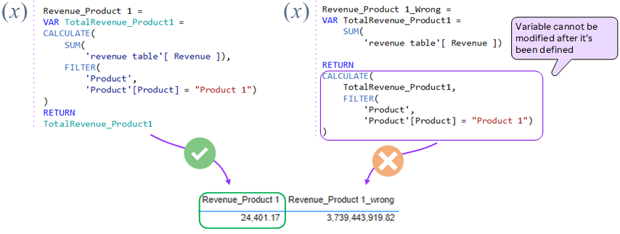

Speed and Performance
-Eliminate redundant columns; keep data tables narrow
•Data tables should ideally only contain only quantitative values and foreign keys; any extra descriptive columns can usually live in a related lookup table
-Imported columns are better than calculated columns
•When possible, create calculated columns at the source (i.e. in your raw database) or within the Query Editor; this is more efficient than processing those calculations in the Data Model
-Minimize iterator functions (FILTER, SUMX, etc.)
•Functions that cycle through each row in a table are “expensive”, meaning that they take time and consume processing power

Recommended Practices
1-Consider learning the important functions first:
DAX has many possible functions, and it can be hard to know where to start. Instead of worrying about all of your options focus on the key functions below that you’ll likely be using most in your calculations
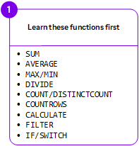
2-Stop memorizing and focus on concepts:
There are lots of DAX resources available online, so you don’t need to memorize everything. Save and use the resources when necessary and instead spend time learning the concepts and patterns.
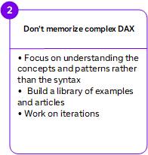
3-Keep your expressions as readable as possible:
The nature of DAX functions means keeping a lot of calculations happening on a single line, so take the time as you progress to keep the code legible and structured. Delete unnecessary elements, use user-friendly names, use variables, and be explicit with your references.
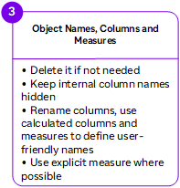
4-Sort measures by categories:
Create a template for the different types of calculated measures that you’ll encounter during the coding process.
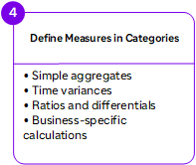
5-Follow these rules:
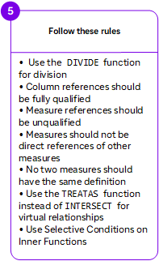

DAX Cheat Sheet

Math and Aggregation Functions
SUM(<column>) | Adds all the numbers in a column.
SUMX(<table>, <expression>)  | Returns the sum of an expression evaluated for each row in a table.
AVERAGE(<column>) | Returns the average (arithmetic mean) of all the numbers in a column
AVERAGEX(<table>, <expression>)  | Calculates the average (arithmetic mean) of a set of expressions evaluated over a table
COUNT(<column>) | Returns the number of cells in a column that contain non-blank values.
COUNTX(<table>, <expression>)  | Counts the number of rows from an expression that evaluates to a non-blank value.
DIVIDE(<numerator>, <denominator> [,<alternateresult>]) | Performs division and returns alternate result or BLANK() on division by 0.
MIN(<column>)  MIN(<expression1>, <expression2>) | Returns a minimum value of a column or between 2 scalar expressions
MINX(<table>,<expression>)  | Returns the smallest value that results from evaluating an expression for each row of a table.
MAX(<column>)  MAX(<expression1>, <expression2>) | Returns a maximum value of a column or between 2 scalar expressions
MAXX(<column>)  | Evaluates an expression for each row of a table and returns the largest value
COUNTROWS([<table>]) | Counts the number of rows in a table or in a table defined by an expression
COUNTX(<table>,<expression>)  | Counts the number of rows that contain a non-blank value or an expression that evaluates to a non-blank value, when evaluating an expression over a table.
DISTINCTCOUNT(<column>) | Counts the number of distinct values in a column.
RANKX(<table>, <expression>[, <value>[, <order>[, <ties>]]])  | Returns the ranking of a number in a list of numbers for each row in the table argument.
MEDIAN(<column>) | Returns the median of a column.
MEDIANX(<table>, <expression>)  | Calculates the median of a set of expressions evaluated over a table.

Filter Functions
The filtering functions let you manipulate data context to create dynamic calculations
CALCULATE(<expression>[, <filter1> [, <filter2> [, …]]]) | Evaluates an expression in a filter context
CALCULATETABLE(<expression>[, <filter1> [, <filter2> [, …]]]) | Evaluates a table expression in a modified filter context
FILTER(<table>, <filter>) | Returns a table that is a subset of another table or expression
ALL([<table> | <column>[, <column>[, <column>[,…]]]]) | Returns all the rows in a table, or all the values in a column, ignoring any filters that might have been applied
ALLEXCEPT(<table>, <column>[, <column>[,.]]) | Returns all the rows in a table except for those rows that are affected by the specified column filters
ALLSELECTED([<tableName> | <columnName>[, <columnName>[, <columnName>[,…]]]] ) | Removes context filters from columns and rows in the current query, while retaining all other context filters or explicit filters
KEEPFILTERS(<expression>) | Modifies how filters are applied while evaluating a CALCULATE or CALCULATETABLE function
SELECTEDVALUE(<columnName>[, <alternateResult>]) | Returns the value when the context for columnName has been filtered down to one distinct value only. Otherwise returns alternateResult.
LOOKUPVALUE(  <result_columnName>,  <search_columnName>,  <search_value>  [, <search2_columnName>, <search2_value>]…  [, <alternateResult>]) | Returns the value for the row that meets all criteria specified by one or more search conditions
REMOVEFILTERS([<table> | <column>][, <column>[, <column>[,…]]]]) | Clear all filters from designated tables or columns

Logical Functions
IF(<logical_test>, <value_if_true>[, <value_if_false>]) | Checks a condition, and returns one value when it's TRUE, otherwise it returns a second value
AND(<logical1>,<logical2>) | Checks whether both arguments are TRUE and returns TRUE if both arguments are TRUE. Otherwise returns false
OR(<logical1>,<logical2>) | Checks whether one of the arguments is TRUE to return TRUE. The function returns FALSE if both arguments are FALSE
NOT(<logical>) | Changes FALSE to TRUE, or TRUE to FALSE
SWITCH(<expression>, <value>, <result>[, <value>, <result>]…[, <else>]) | Evaluates an expression against a list of values and returns one of multiple possible result expressions.
COALESCE(<expression>, <expression>[, <expression>]…) | Returns the first expression that does not evaluate to BLANK. If all expressions evaluate to BLANK, BLANK is returned
TRUE() | Returns the logical value TRUE
Date and Time Functions
These functions help you create calculations based on dates and time
CALENDAR(<table>, <filter>) | Returns a table with a single column named "Date" that contains a contiguous set of dates
DATE(<year>, <month>, <day>) | Returns the specified date in datetime format
DATEDIFF(<Date1>, <Date2>, <Interval>) | Returns the number of interval boundaries between two dates
DATEVALUE(date_text) | Converts a date in text format to a date in datetime format
DAY([<date>) | Returns the day of the month, a number from 1 to 31
WEEKNUM(<date>, <return_type>) | Returns the week number for the given date according to the return_type value. The week number indicates where the week falls numerically within a year.  There are two systems used for this function:  -System 1 - The week containing January 1 is the first week of the year and is numbered week 1.  -System 2 - The week containing the first Thursday of the year is the first week of the year and is numbered as week 1. This system is the methodology specified in ISO 8601, which is commonly known as the European week numbering system.
MONTH(<datetime>) | Returns a number from 1 to 12 representing a month
QUARTER(<date>) | Returns a number from 1 to 4 representing a quarter

Relationship Functions
Functions in this category are for managing and utilizing relationships between tables
CROSSFILTER(<left_column>, <right_column>, <crossfiltertype>) | Returns a summary table for the requested totals over a set of groups
RELATE(<column>) | Returns a related value from another table
RELATEDTABLE(<tableName>) | Evaluates a table expression in a context modified by the given filters
USERELATIONSHIP(<columnName1>,  <columnName2>) | Specifies the relationship to be used in a specific calculation as the one that exists between columnName1 and columnName2

Table Manipulation Functions
These functions return a table or manipulate existing tables
SUMMARIZE (<table>, <groupBy_columnName>[, <groupBy_columnName>]…[, <name>, <expression>]…) | Returns a table that is a subset of another table or expression
DISTINCT(<table>) | Returns a table by removing duplicate rows from another table or expression
ADDCOLUMNS(<table>, <name>, <expression>[, <name>, <expression>]…) | Adds calculated columns to the given table or table expression
SELECTCOLUMNS(<Table>, [<Name>], <Expression>, <Name>], …) | Returns a table with selected columns from the table and new columns specified by the DAX expressions
CROSSJOIN(<table>, <table>[, <table>]…) | Returns a table that contains the Cartesian product of all rows from all tables in the arguments. The columns in the new table are all the columns in all the argument tables
GROUPBY (<table> [, <groupBy_columnName> [, <groupBy_columnName> [, …]]] [, <name>, <expression> [, <name>, <expression> [, …]]]) | The GROUPBY function is similar to the SUMMARIZE function. However, GROUPBY does not do an implicit CALCULATE for any extension columns that it adds. GROUPBY permits a new function, CURRENTGROUP, to be used inside aggregation functions in the extension columns that it adds. GROUPBY is used to perform multiple aggregations in a single table scan
INTERSECT(<table_expression1>, <table_expression2>) | Returns the row intersection of two tables, retaining duplicates
VALUES(<TableNameOrColumnName>) | When the input parameter is a column name, returns a one-column table that contains the distinct values from the specified column. Duplicate values are removed and only unique values are returned. A BLANK value can be added. When the input parameter is a table name, returns the rows from the specified table. Duplicate rows are preserved. A BLANK row can be added
UNION(<table_expression1>, <table_expression2> [,<table_expression>]…) | Creates a union (join) table from a pair of tables.
Table constructor | Returns a table of one or more columns.  { <scalarExpr1>, <scalarExpr2>, … }  { ( <scalarExpr1>, <scalarExpr2>, … ), ( <scalarExpr1>, <scalarExpr2>, … ), … }

Text Functions
CONCATENATE(<text1>, <text2>) | Joins two text strings into one text string
CONCATENATEX(<table>, <expression>[, <delimiter> [, <orderBy_expression> [, <order>]]...])  | Concatenates the result of an expression evaluated for each row in a table
EXACT(<text1>,<text2>) | Compares two text strings and returns TRUE if they are exactly the same, otherwise returns FALSE. EXACT is case-sensitive but ignores formatting differences. EXACT is case-sensitive
FIND(<find_text>, <within_text>[, [<start_num>][, <NotFoundValue>]]) | Returns the starting position of one text string within another text string. FIND is case-sensitive
FORMAT(<value>, <format_string>[, <locale_name>]) | Converts a value to text according to the specified format
LEFT(<text>, <num_chars>) | Returns the specified number of characters from the start of a text string
RIGHT(<text>, <num_chars>) | RIGHT returns the last character or characters in a text string, based on the number of characters you specify
LEN(<text>) | Returns the number of characters in a text string
LOWER(<text>) | Converts all letters in a text string to lowercase
UPPER (<text>) | Converts a text string to all uppercase letters
MID(<text>, <start_num>, <num_chars>) | Returns a string of characters from the middle of a text string, given a starting position and length
REPLACE(<old_text>, <start_num>, <num_chars>, <new_text>) | REPLACE replaces part of a text string, based on the number of characters you specify, with a different text string
SEARCH(<find_text>, <within_text>[, [<start_num>][, <NotFoundValue>]]) | Returns the number of the character at which a specific character or text string is first found, reading left to right. Search is case-insensitive and accent sensitive
SUBSTITUTE(<text>, <old_text>, <new_text>, <instance_num>) | Replaces existing text with new text in a text string
TRIM(<text>) | Removes all spaces from text except for single spaces between words

Information Functions
DAX information functions look at the cell or row that is provided as an argument and tells you whether the value matches the expected type. For example, the ISERROR function returns TRUE if the value that you reference contains an error.
COLUMNSTATISTICS () | Returns a table of statistics regarding every column in every table in the model
CONTAINS(<table>, <columnName>, <value>[, <columnName>, <value>]…) | Returns true if values for all referred columns exist, or are contained, in those columns; otherwise, the function returns false
HASONEFILTER(<columnName>) | Returns TRUE when the number of directly filtered values on columnName is one; otherwise returns FALSE.
HASONEVALUE(<columnName>) | Returns TRUE when the context for columnName has been filtered down to one distinct value only. Otherwise is FALSE
ISBLANK(<value>) | Checks whether a value is blank, and returns TRUE or FALSE
ISCROSSFILTERED(<TableNameOrColumnName>) | Returns TRUE when the specified table or column is cross-filtered
ISEMPTY(<table_expression>) | Checks if a table is empty
ISERROR(<value>) | Checks whether a value is an error, and returns TRUE or FALSE
ISFILTERED(<TableNameOrColumnName>) | Returns TRUE when the specified table or column is being filtered directly
USERPRINCIPALNAME() | Returns the user principal name

Reference

SQLBI: Free resource to learn all DAX
https://www.sqlbi.com/

Microsoft: Official reference documentation
https://learn.microsoft.com/en-us/dax/

DAX Formatter: Make your formulas readable
https://www.daxformatter.com/

DAX Cheat Sheet:
https://community.powerbi.com/t5/Data-Stories-Gallery/DAX-Cheat-Sheet-Success-of-CSS-Selector/m-p/2480476

Power BI docs
https://powerbidocs.com/power-bi-dax-functions/

